SUPPLEMENTAL MATERIAL

Protocol Algorithm for Liver Perfusion with HOPE 2
Comparison between EAD and EASE in predicting graft failure at 90 days 3
Predictive factors of EAD development among donor and recipient variables 4
Predictive factors of EAD development among perfusate variables 5

Protocol Algorithm for Liver Perfusion with HOPE

Supplemental Figure 1 The protocol algorithm for treatment of the study group undergoing preservation with hypothermic oxygenated perfusion (HOPE)

Comparison between EAD and EASE in predicting graft failure at 90 days

Supplemental Table 1 Comparison between EAD and EASE score in predicting graft failure at 90 days
 | Graft failure at 90 days  Yes No |  | RD (95% IC) | p value | AUROC
EAD  yes – no. (%)  no – no. (%) | 6 (23%)  2 (2%) | 20 (77%)  82 (98%) | -0.207 (-0.372 - -0.042) | 0.003 | 0.777
EASE  Median  IQR | -1.50  -2.15 - -1.00 | -3.50  -4.10 - -2.90 | -0.532 (-0.901 - -0.164) | 0.000 | 0.938

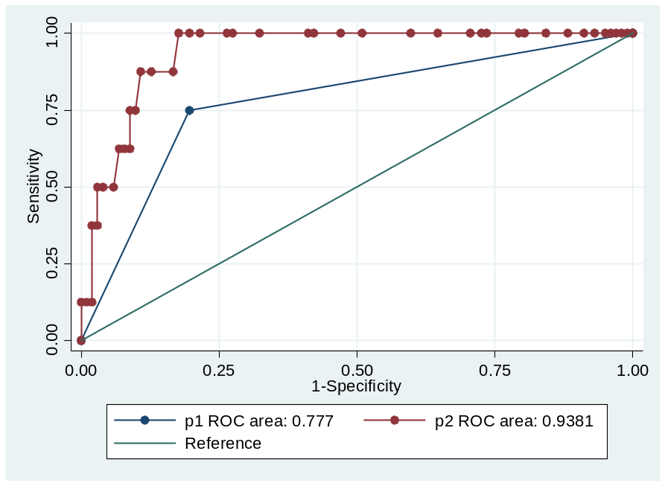

Supplemental Figure 2 Comparison between EAD (blue line) and EASE (score predicting graft failure at 90 days

Predictive factors of EAD development among donor and recipient variables

Supplemental Table 2 Uni- and multivariate analysis of variables predicting EAD development
Variable | Univariate logistic regression |  | Stepwise multivariate regression
 | RD (CI 95%) | P value | RD (CI 95%) | P value
HOPE | 0.22 (0.07-0.37) | 0.009 | 0.23 (0.09 – 0.38) | 0.005
Age | - | n.s.
Sex | - | n.s.
BMI | - | n.s.
Portal thrombosis | - | n.s.
MELD score | - | n.s.
Macrosteatosis | -0.01 (-0.15 - -0.01) | 0.033 | n.s.
Microsteatosis | -0.06 (-0.01 - -0.01) | 0.078 | n.s.
Fibrosi (Metavir) | - | n.s.
Ishak Grade | - | n.s.
DRI | 0.33 (0.21 – 0.46) | 0.079 | n.s.
CIT | - | n.s.
Operation time | -0.01 (-0.003 - 0.01) | 0.02 | -0.01 (-0.01 - 0.001) | 0.009

Predictive factors of EAD development among perfusate variables

Supplemental Table 3 Uni- and multivariate analysis of perfusion variables predicting EAD development
Variable |  | Median (IQR) | Univariate logistic regression |  | Stepwise multivariate regression
 |  |  | RD (CI 95%) | P value | RD (CI 95%) | P value
Flushing
pH | at T0  at T1 | 7.02 (6.98 – 7.07)  7.03 (6.97 – 7.07) | - | n.s.
pCO2 (mmHg) | at T0  at T1 | 5 (5 – 5)  7.5 (6 – 9) | -  -0.001 (-0.004 – 0.002) | n.s.  0.009 | n.s.
pO2 (mmHg) | at T0  at T1 | 245 (229 – 254)  202 (170 – 259) | - | n.s.
Glucose (mg/dL) | at T0  at T1 | 6 (3 – 12)  147 (121 – 176) | -  -0.002 (-0.005 – 0.001) | n.s.  0.053 | n.s.
Lactate (mmol/L) | at T0  at T1 | 0.2 (0.2 - 0.3)  2.3 (1.9 – 2.8) | -  -0.011 (-0.285 – 0.007) | n.s.  0.012 | -0.011 (-0.285 - 0.007) | 0.012
Recycle
pH | at T0  at T1 | 7.17 (7.11 – 7.24)  7.12 (7.09 – 7.16) | - | n.s.
pCO2 (mmHg) | at T0  at T1 | 5 (5 – 6.5)  6 (5 – 7) | - | n.s.
pO2 (mmHg) | at T0  at T1 | 271 (183 – 454)  354 (234 – 520) | - | n.s.
Glucose (mg/dL) | at T0  at T1 | 194 (187 – 210)  254 (209 – 293) | - | n.s.
Lactate (mmol/L) | at T0  at T1 | 1.55 (0.65 – 2.25)  3.05 (2.25 – 4.20) | -  0.011 (-0.025 – 0.003) | n.s.  0.014 | n.s.

